Moscow State Circus
“I saw the circus in posters in shops and the real circus on Hartham in Hertford. The big top was different colours, psychedelic.

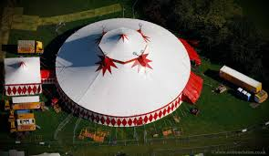 | 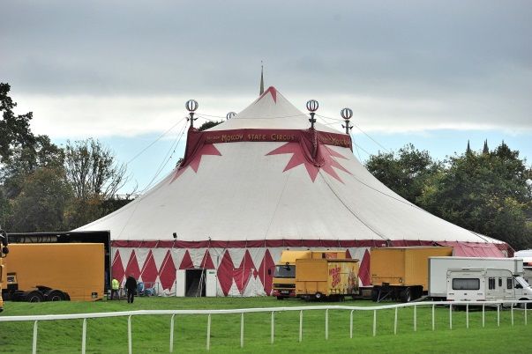

I asked my Mum if I could go. I showed Mum the leaflet and asked again if I could go.
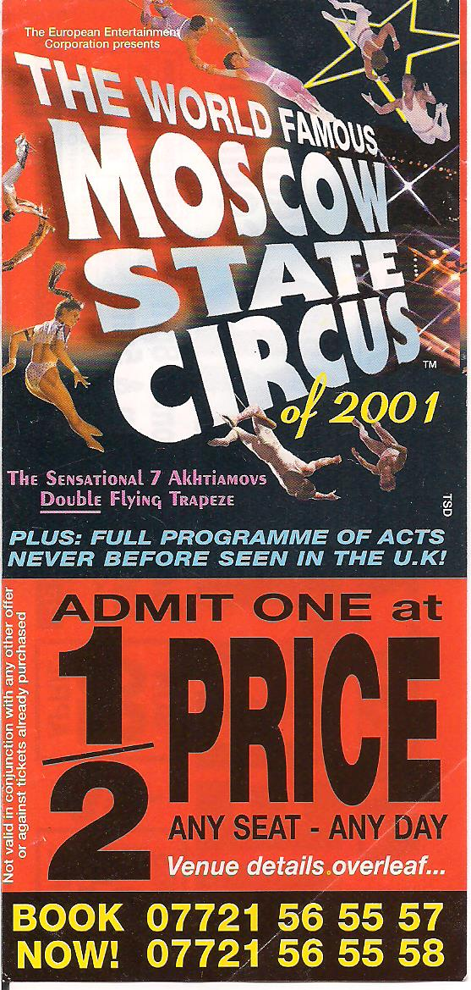

Mum gave me some money, I went by myself and bought my own ticket.
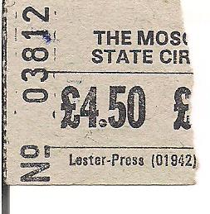
I sat at the back and watched the show.
During the show they asked ‘who wants to hold the trapeze rope’? I put my hand up and went into the ring.
All the spectators saw me helping and holding the rope. The acrobats did their act and I spun the rope round and round. I held the rope tight, with both my hands and spun it.
The lady acrobat went round and round on the rope. I used all my strength.
I felt I’d achieved something, I felt excited and good. When she’d finished, I went back to my seat and the audience applauded. I went back to my seat to watch the rest of the show.
It was a human circus with juggling and acrobats, no animals.
At the end of the performance I went home. I told my Mum all about what had happened. She was pleased that I’d helped. I went to bed happy. Later in the week, I went to watch the show one last time, with Mum and Anne. This time, I didn’t help, I just watched. The show was good and Mum and Anne enjoyed it all too.
The circus moved on to another place. I didn’t know where they went next. I felt a little bit sad that they had gone. I only helped once at the performance, I never got to know anybody’s name.
I spoke to a Russian Lady about Russian dolls and asked what Russian doll was in Russian and she told me, ‘Marioshka’.
I don’t know where they came from. Maybe Moscow, when I discovered the circus had gone, I almost cried. I was with Mum and Anne at the time. I stopped myself from crying. I’m glad that I’ve got that happy memory and I could help the lady acrobat at the circus.”
We now know that the lady’s name was either Tatiana or Ekaterina Rubtsova – Tatiana was Ekaterina’s mother.

